***Our Mission Name Shall Be…***

***“POSEIDON”***

***Step 1: Location***

Our location is:

Lunar South Hemisphere, close to Lunar South Pole

Why we selected this location:

Lunar poles are known to have water ice present, but we have to take into consideration that the GLEE LunaSats can work only in direct sunlight, hence not choosing the pole itself.

Moreover this location is the best for our science objectives.

***Step 2: Science!***

Our science objectives shall be:

Primary Science Objectives:

-LunaSat orientation measurement

-Detecting meteorite impacts

-Testing for water presence using the CAP sensor

Secondary Science Objectives:

-Measuring Moonquakes

-Detecting differentiating between moonquakes and meteorite impacts

-Assessing the magnetic environment - cooperation with other LunaSats

(in order to search for magnetic metals within the lunar regolith/surface)

-Checking how regolith dust impacts the LunaSat solar cell output power

Our primary sensors are:

Capacitive Sensor

Accelerometer

Our secondary sensors are:

Magnetometer Sensor

Solar Panel Voltage Output

***Step 3: Imagine Data Processing***

The type of data and how often we are collecting it is:

As often as possible:

-How much electricity do LunaSat panels produce

-Lunar impact detection(change in Accelerometer reading)

Periodically or when a surface impact is detected

-Ice/water detection in regolith(Capacitive Sensor)

-After detecting the impact, checking whether it is a metal-containing body ((change in Magnetometer reading)

***Step 5: Imagine Data Processing (IDP)***

Here are some graphs of our expected data with key events labeled!

Detection of ice / water after touching the ground / winding regolith dust on the sensor:

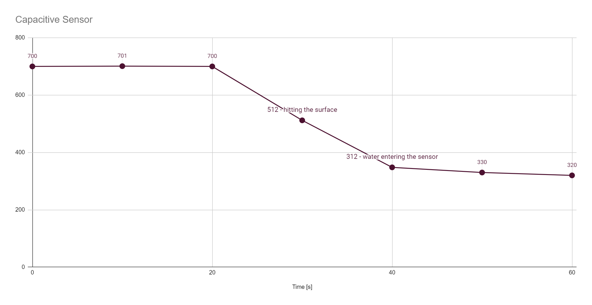Detection of a small meteorite impact near LunaSat:

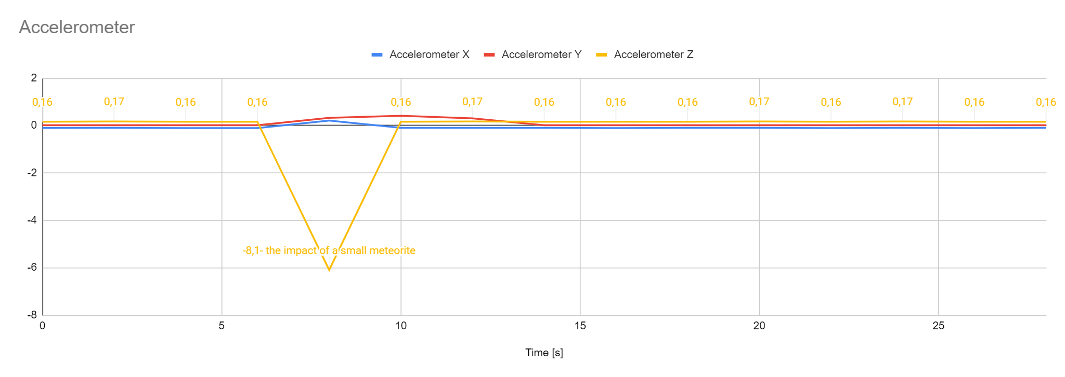

Detection of metal in a meteorite near LunaSat (similarly, we can locate a nearby LunaSat or a rock containing metals. If we detected a meteorite impact but did not detect metal, it could mean it was a block of ice)

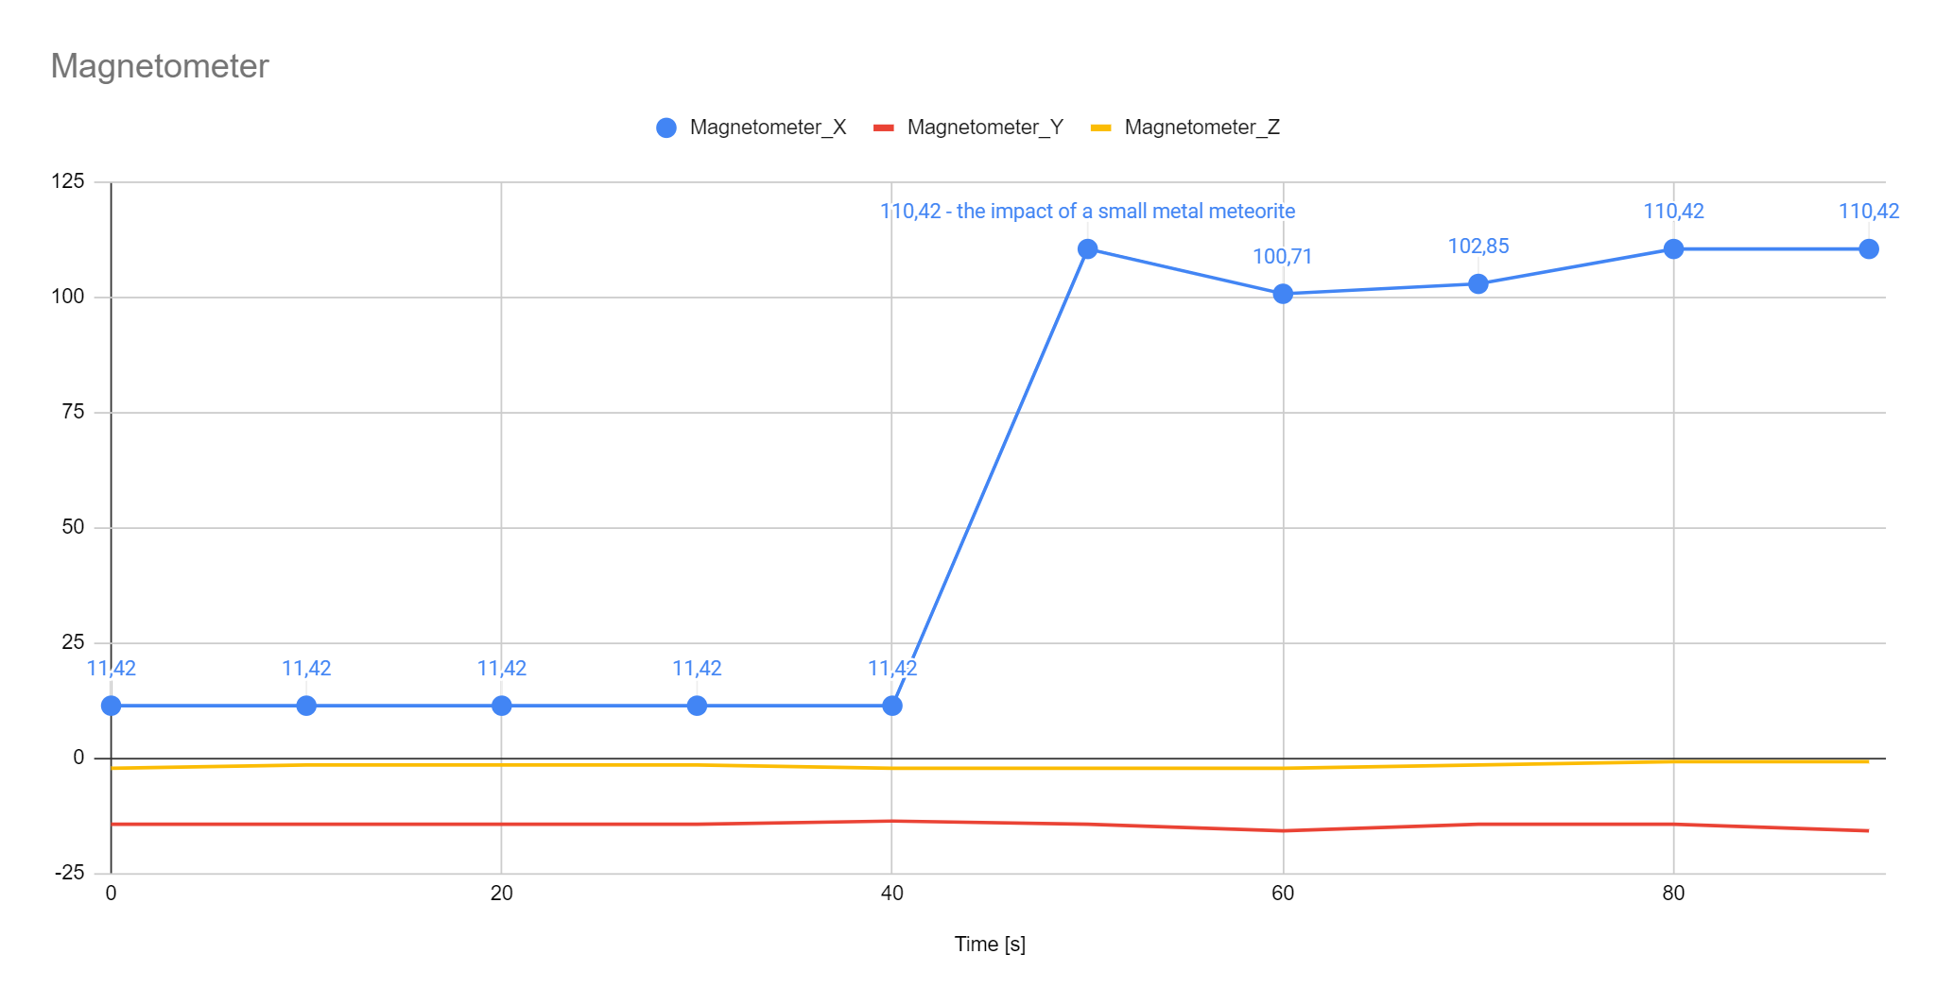

Covering the panel with Moon dust

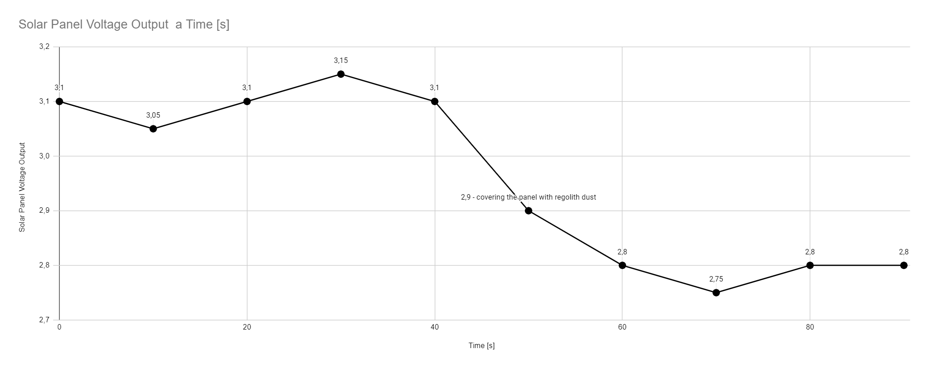

***Step 4: Mission Statement***

Our mission statement is:

“To find a place for settle”

“Looking for water and meteorites”

“Pursuing Lunar Water, Meteor Awareness”

“Looking for ice from top to bottom”

“Explore ground, monitor sky”